Acme Network Setup and Testing

By Jayviar Laporte

Hello and Welcome! Below is the step-by-step documentation on how we will be setting up our servers

First steps

Setting up Servers:

* To start we will be downloading two different distros. One will be CentOS 9 and the other will be Ubuntu Server. (*If not already installed, it is recommended to download a virtual machine. VMware is recommended as well as Virtual Box, links for both will be listed at the bottom of the page*).

1)

To install CentOS and Our second distro we will First Download the version/iso file that is listed from the link below with respect to whatever device or VM you will be using in this demo the second OS we are installing will be Ubuntu Server -

-<https://www.centos.org/download/>

-<https://ubuntu.com/download/server>

2)

Next up is uploading our newly downloaded iso file to our virtual machine. We will open our Virtual Machine and create a new Machine. When prompted with the Select Installation method, we will choose the “Install from disc or image” option then choose the CentOS file Or Ubuntu Server File. Below is visual representation of what we just did-

*\*Below is us creating a new machine and choosing the installation method*

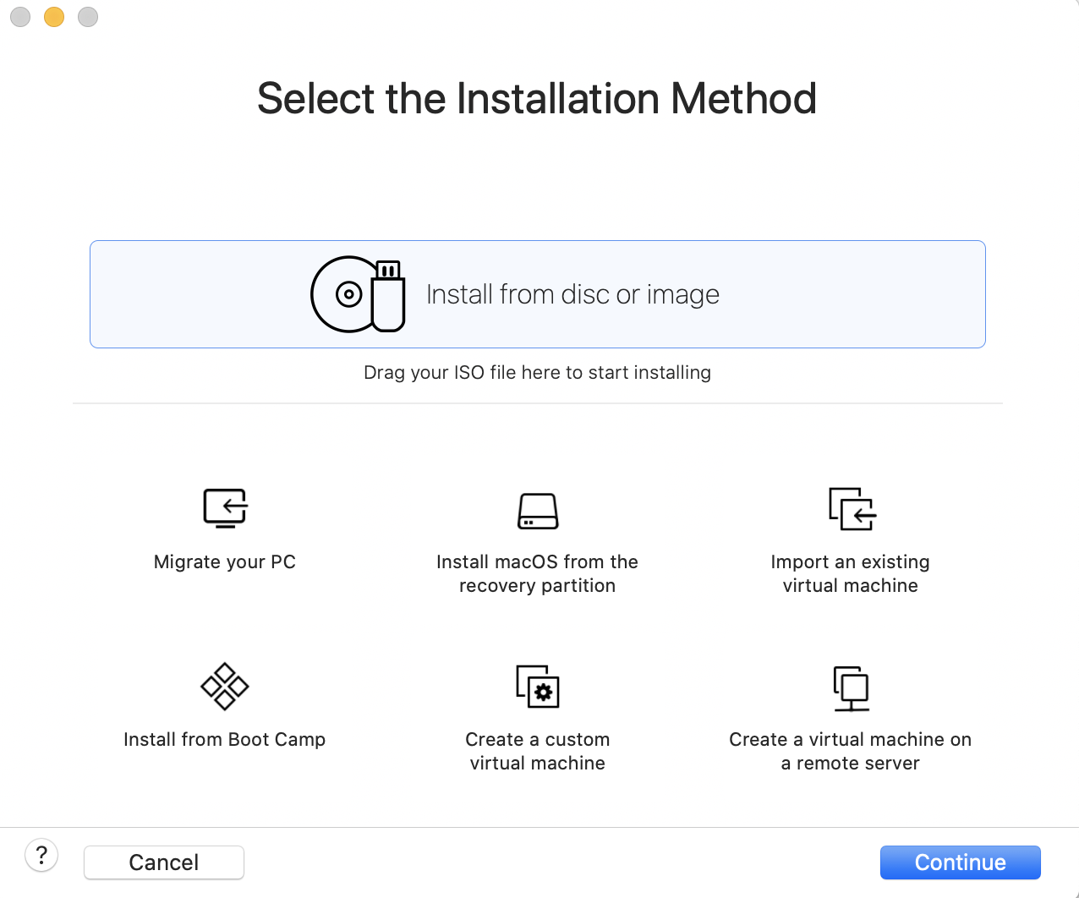

*\*Below is us uploading the newly downloaded iso file for CentOS*

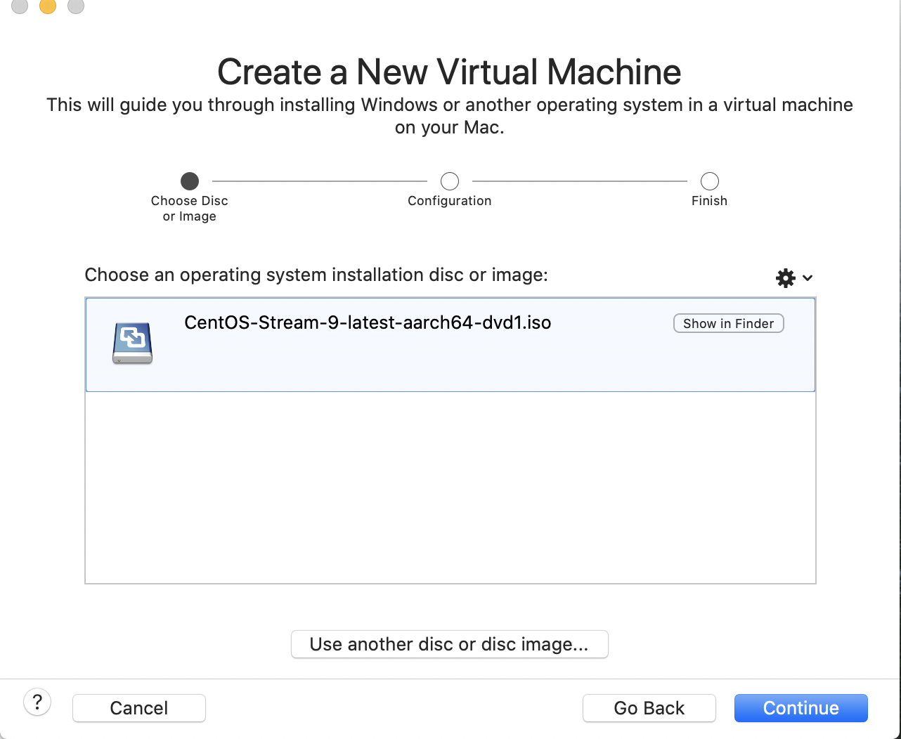

*\*Below is us choosing the ubuntu server option*

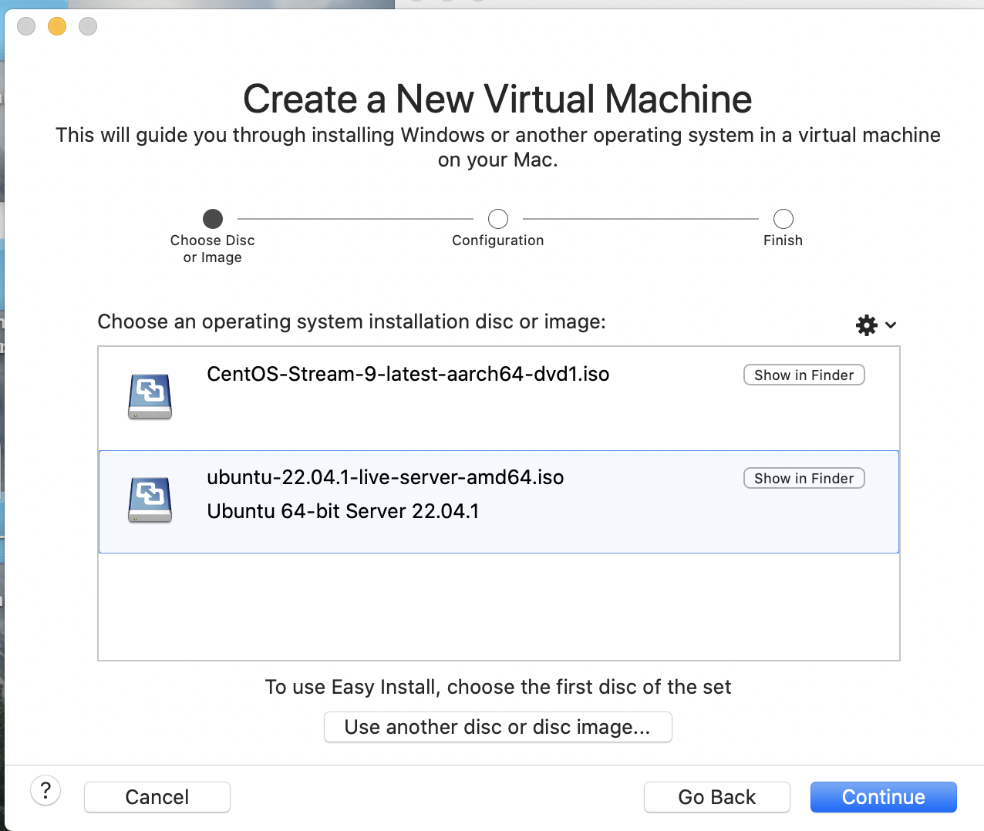

3)

Next, We will click continue and on the configuration page we will select the operating system respective to what we downloaded. In this case it is CentOS. NOTE: if you are using CentOS 9 or later you may not see an option for that just yet depending on the Version and or Virtual machine you are on. If this is the case choose the option “Other” ---> “Other 64 bit”. We do the same thing for ubuntu but with the option “Linux” ---> “Ubuntu server”

Centos

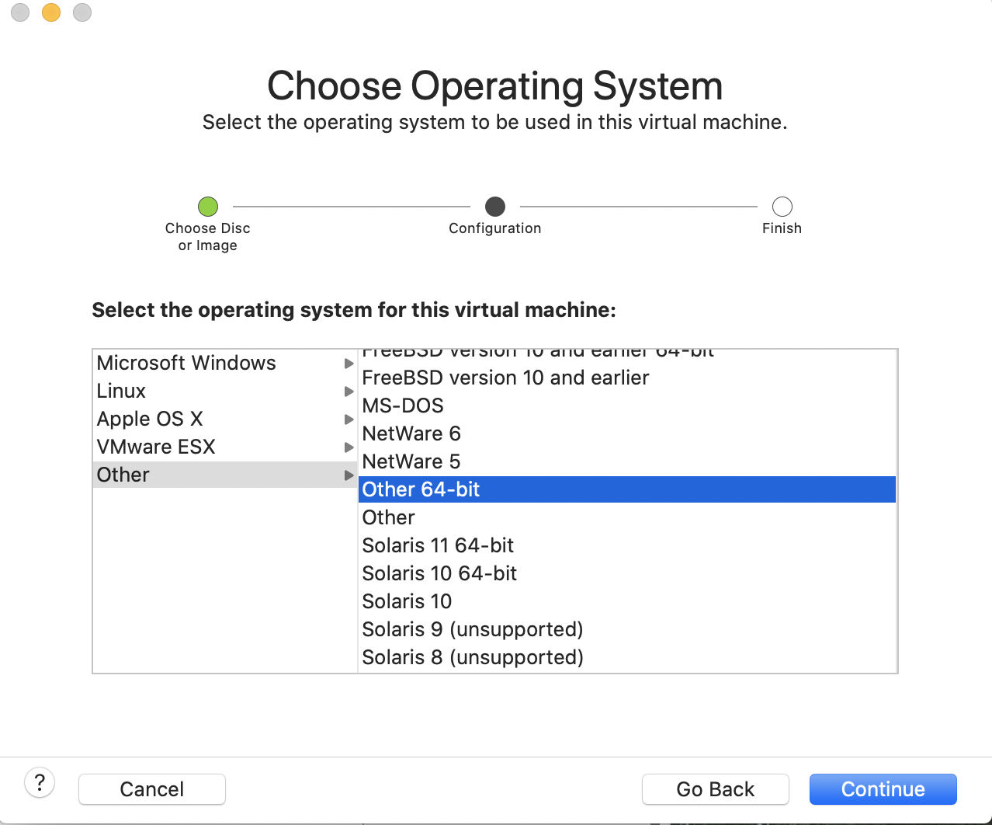

Ubuntu

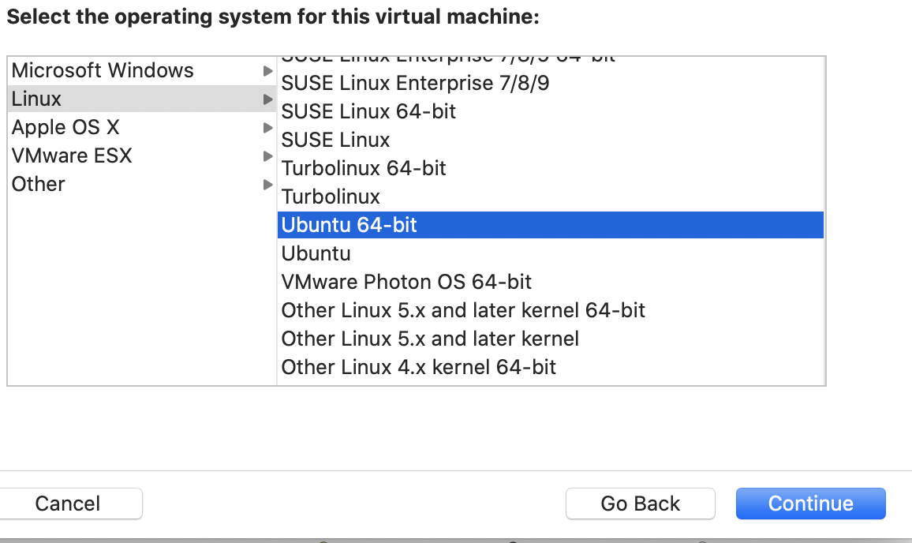

4)

The Final steps are to continue with the legacy Bios option selected. Then customize the settings to whatever you desire or whatever may need to be changed to fit your computer's standards.

Centos

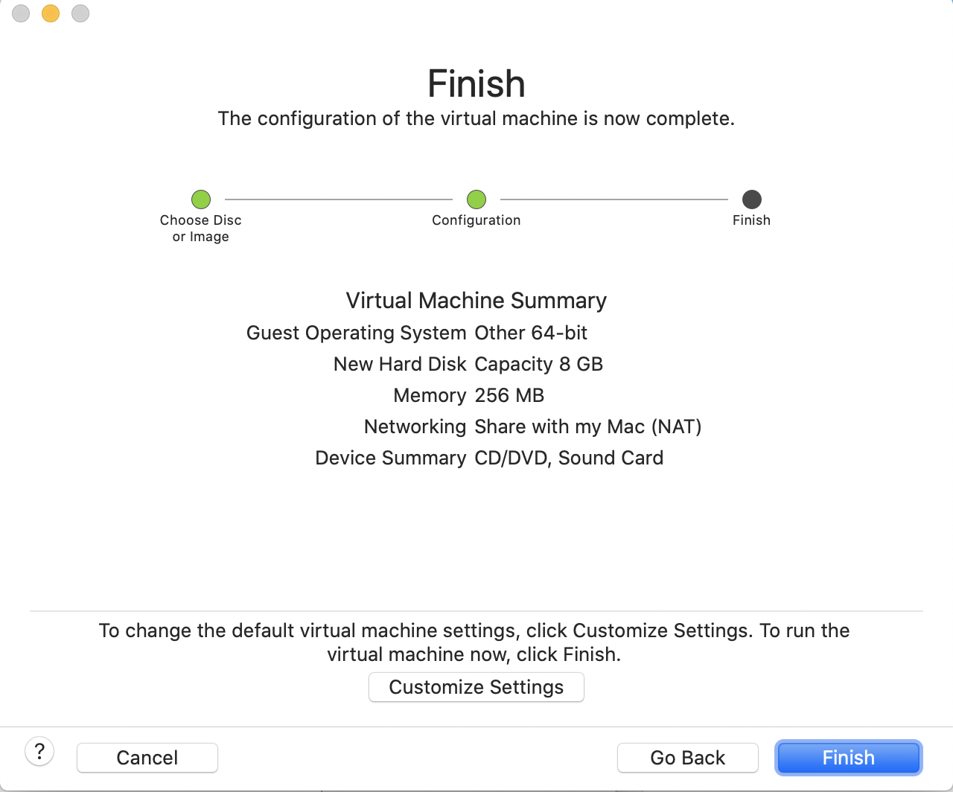

Ubuntu

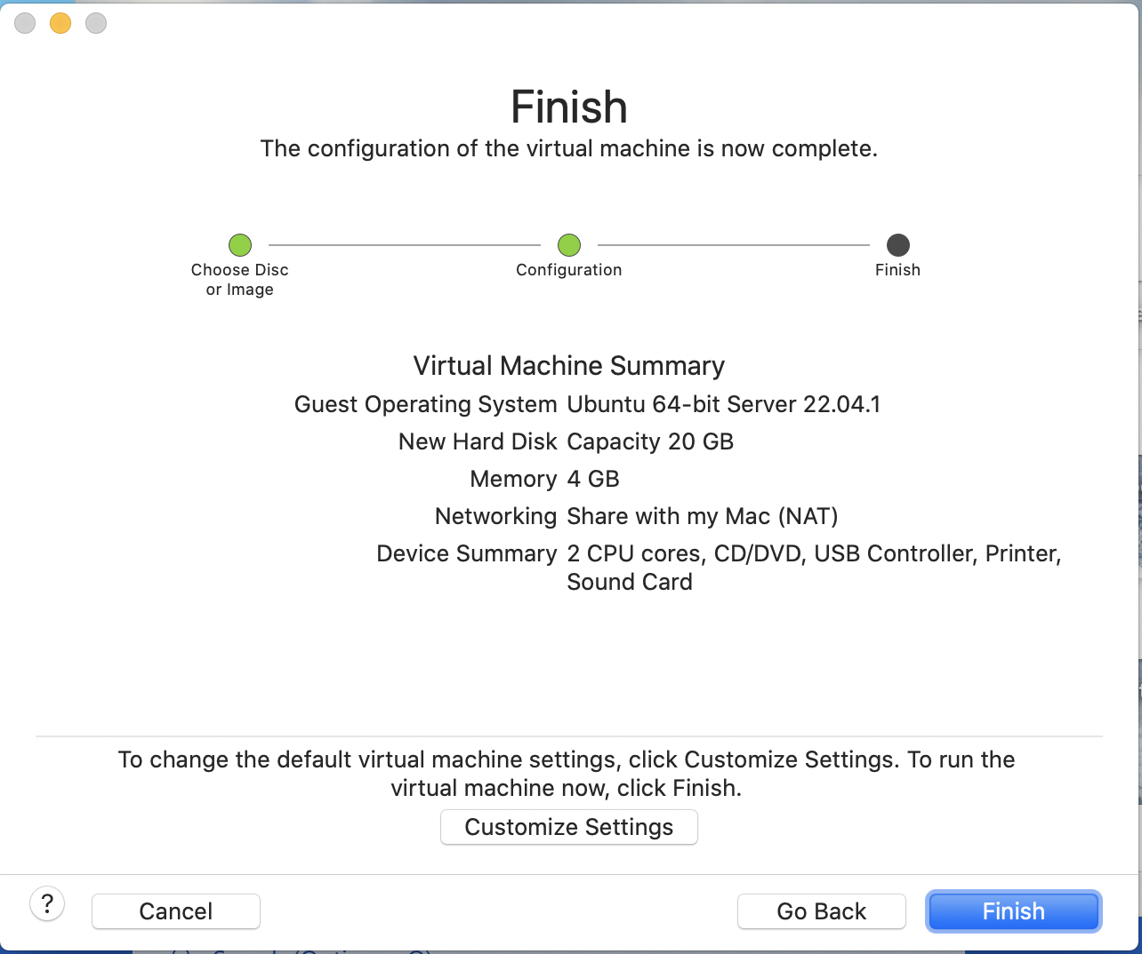

5)

Next Let us set up some login info for our server. Turn on both servers and boot them up. Then we will go through some of the first time bootup steps

Centos-

Once booted up in Centos we are going to be prompted with what language we want.

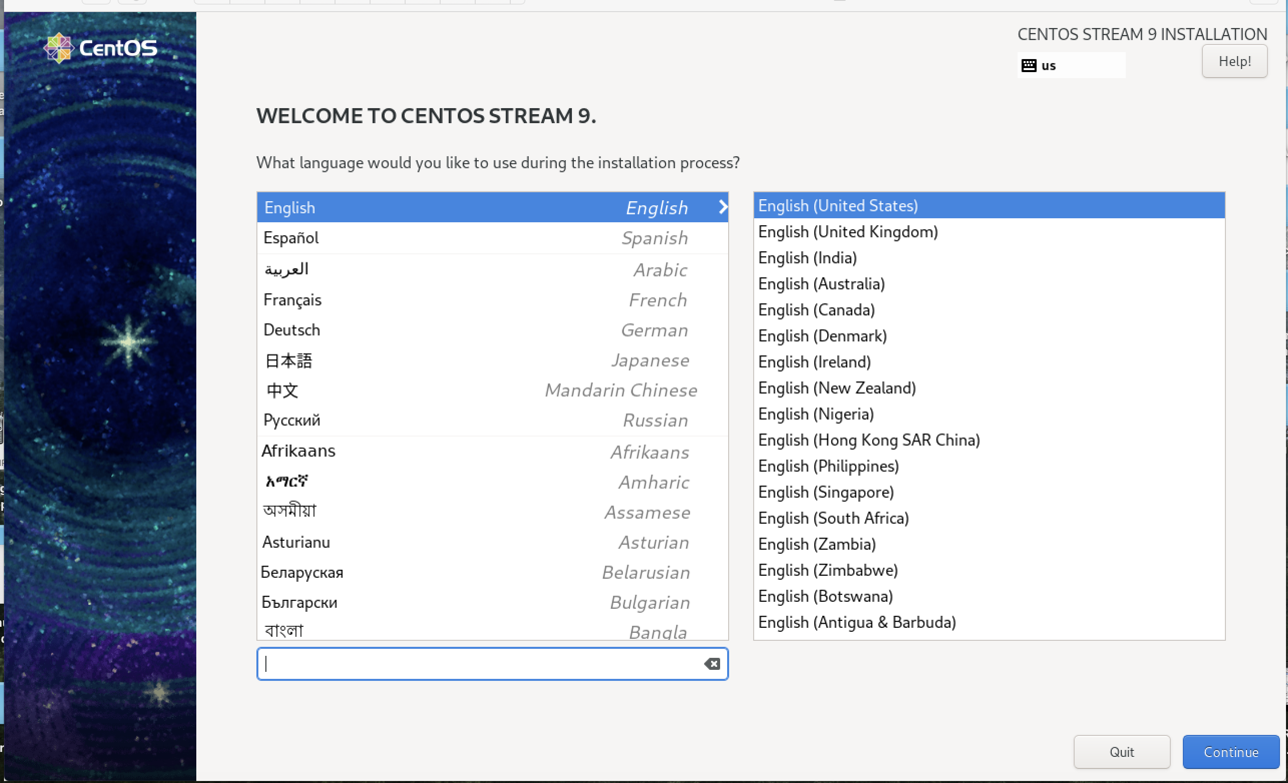

Next:

We are going to customize some of the settings for our virtual machine in order to continue. This will include installation destination, root password, and user creation. There are also many other things we can customize here to whatever we wish like the keyboard layout, time/date, and the network our virtual machine is on

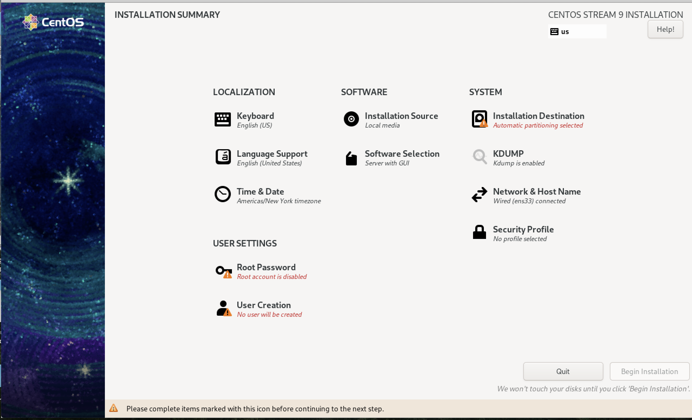

User Creation:

In order to continue, we must select user creation and validate if we want to create another user. Fill this out if you would like to create a user. If not, you can click done and close out of this, and no new user will be created upon booting up. We can also select the option of making the user an administrator or require a password at all for this user. Or both or even neither.

*Note: if user is not made now, we will be prompted with a screen identical to what we see below and need to create one before using the VM*

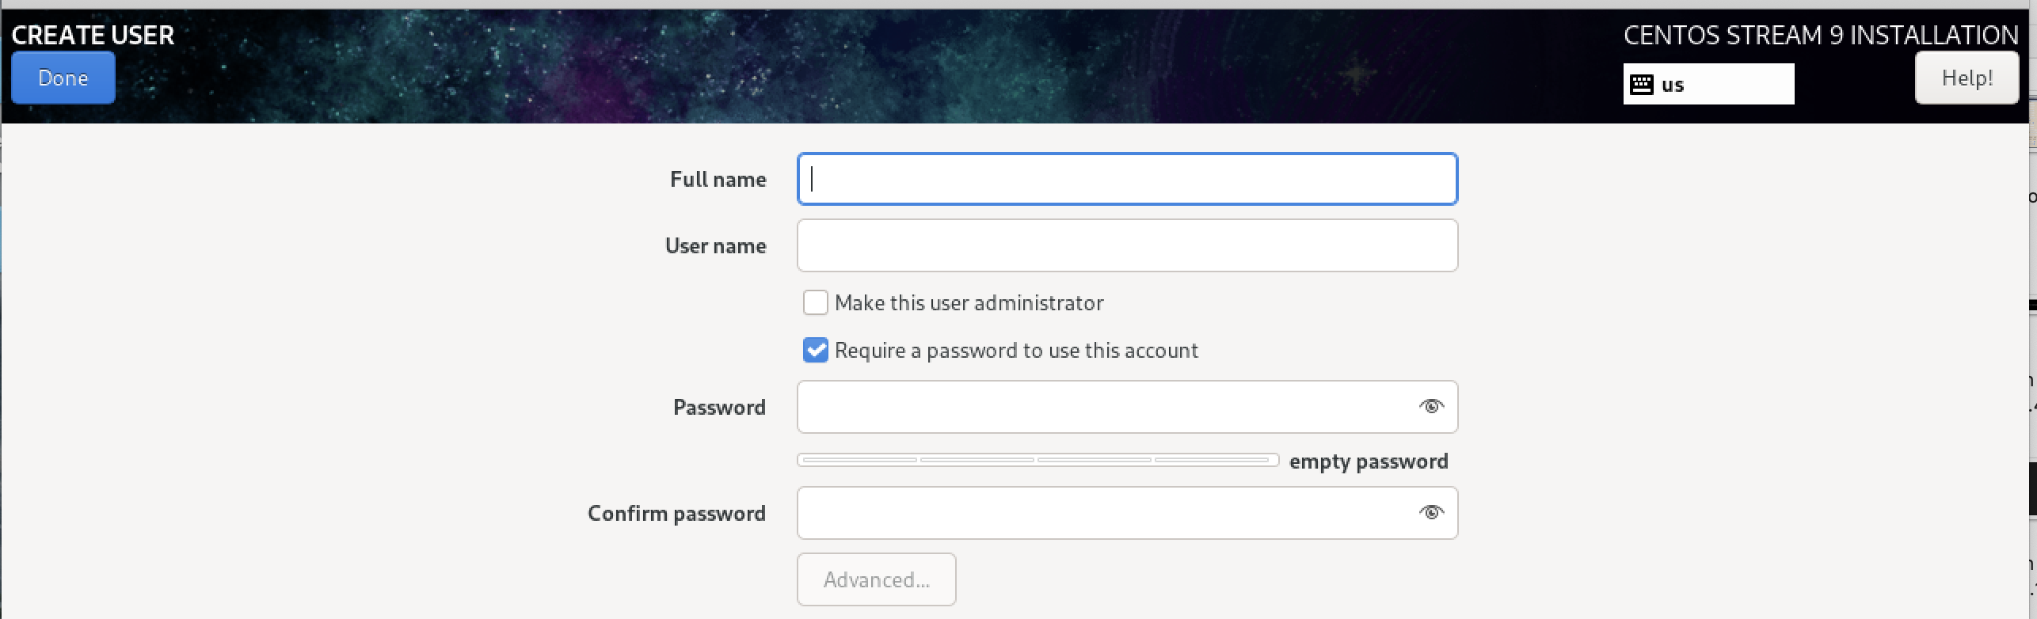

Root Password:

Next, we will set up a root password. This makes it so that only those who have this password for root will be able to have access to administering the system. For this We simply input whatever we want it to be. We also have the choice to allow ssh with password, or lock root account or both.

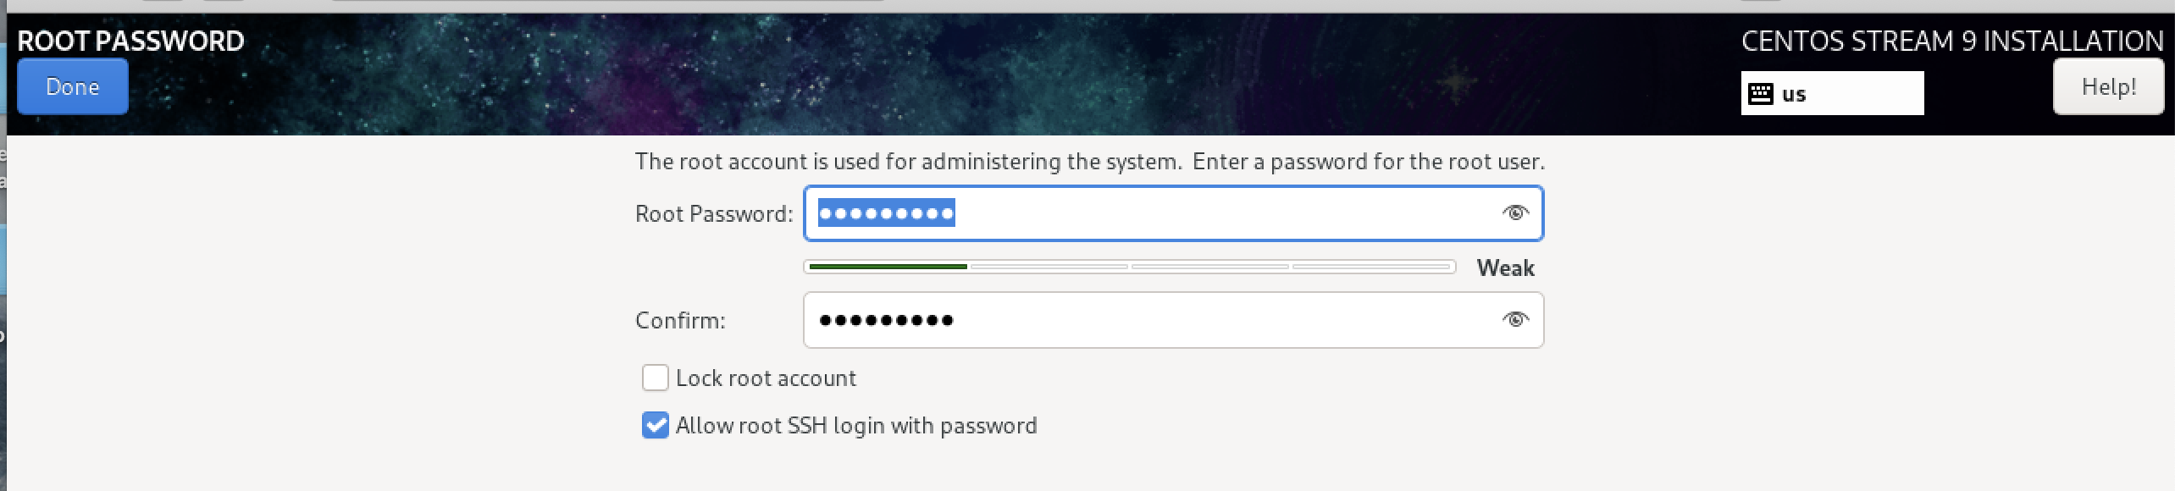

Installation Destination:

Here we can edit whatever it is we want regarding storage. We see that we have a standard disk that is our Virtual machine. We also can add disks to this below it. If we want to, we can switch the automatic storage configuration to custom and edit how much we have. For the user previewing this. It may change depending on circumstances, for this we are leaving it automatic. Once done click done.

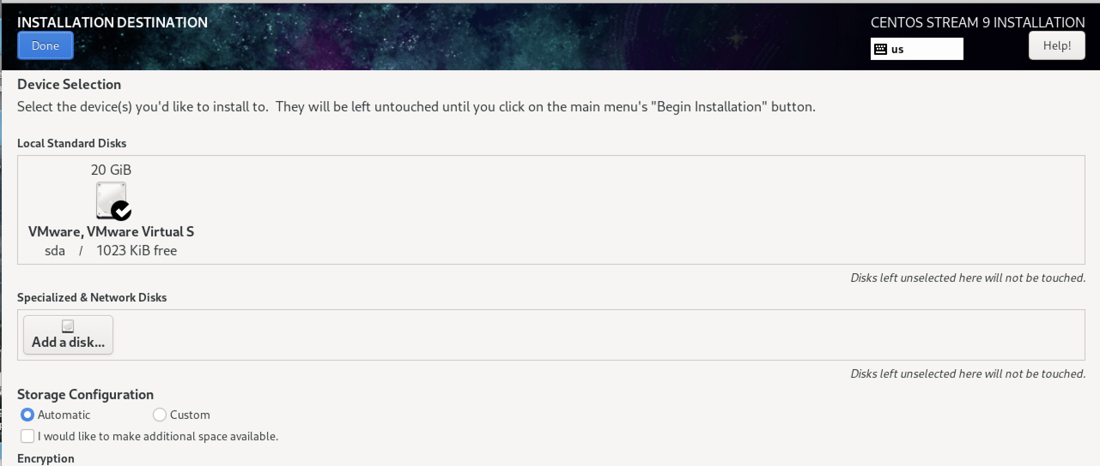

Once Finished we can continue to our installation!

After clicking “done”. Click Begin installation and wait for the process to be done.

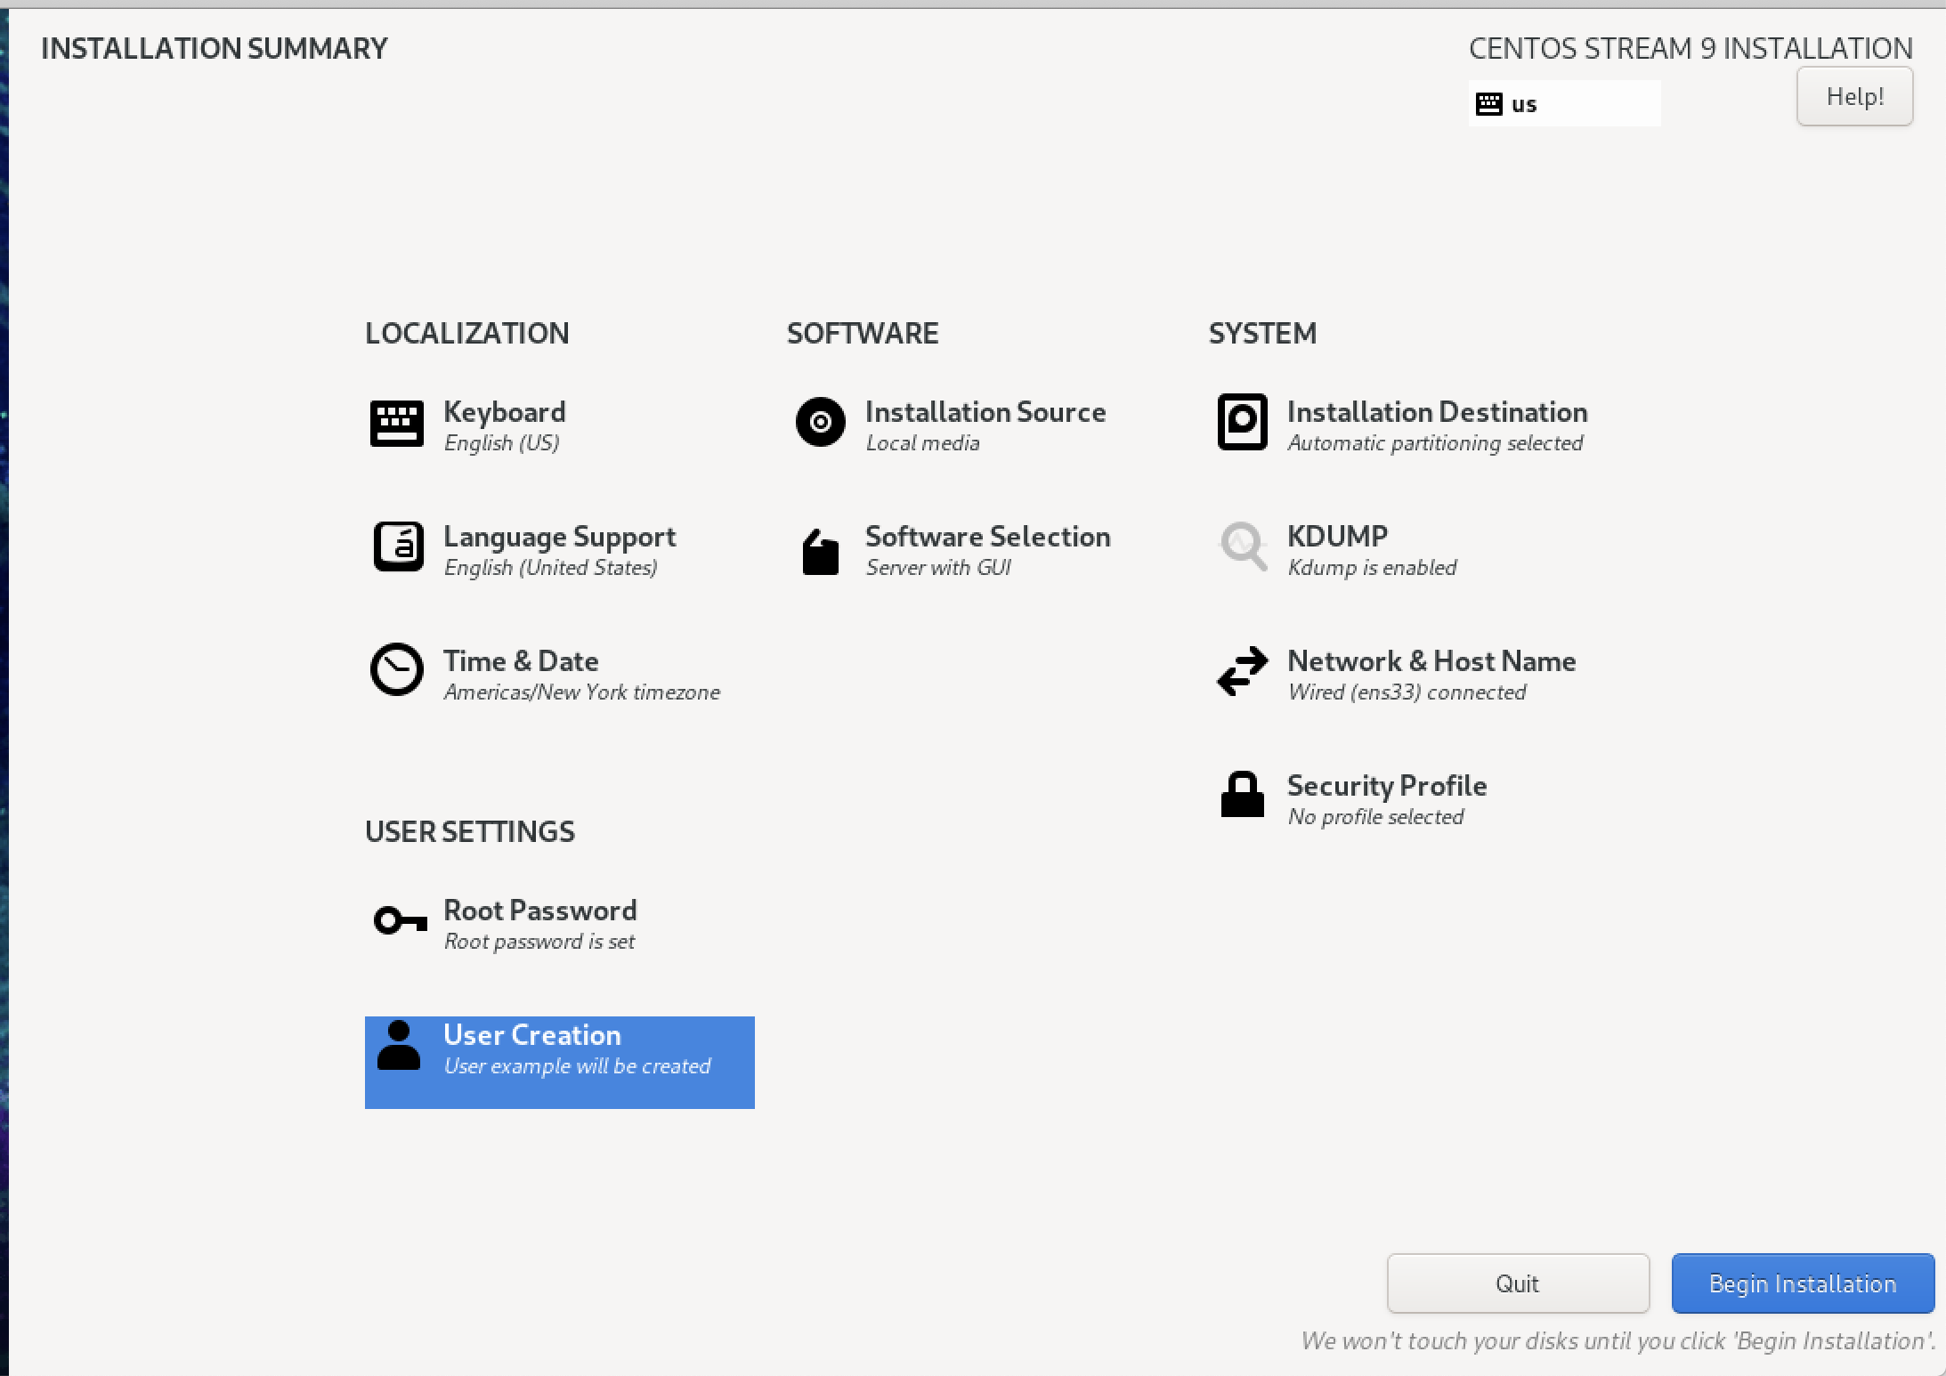

Once Finished, we will be prompted to enter our username and password. If a user was not created, you will be prompted to make one in order to access the Virtual machine

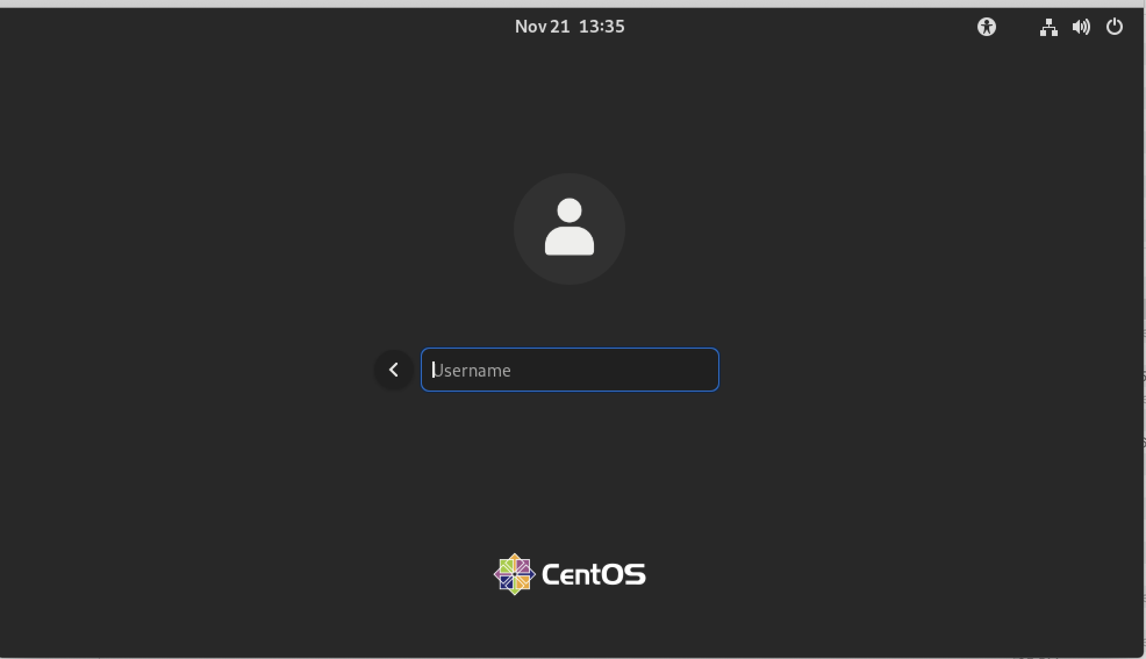

Once logged in we can see a multitude of different applications that are on here like cmd, Firefox, and many other things. Explore!

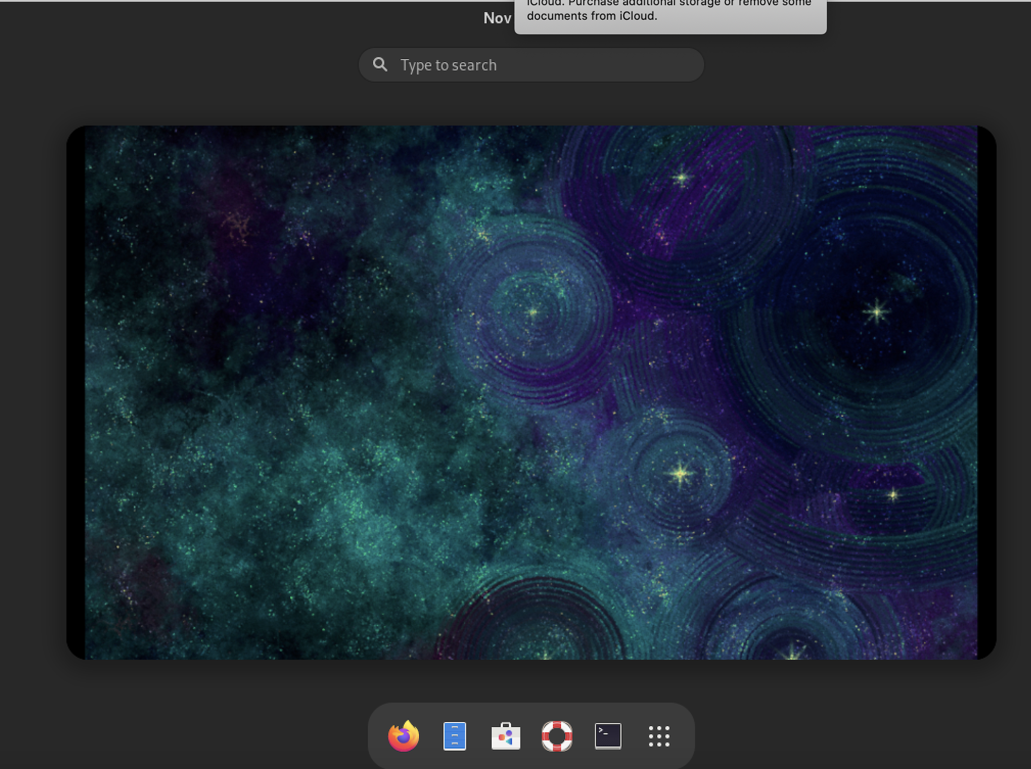

Ubuntu-

For Ubuntu we are going to be prompted different things than our centos server. Once Ubuntu is booted, we are going to be prompted with the language screen such as this:

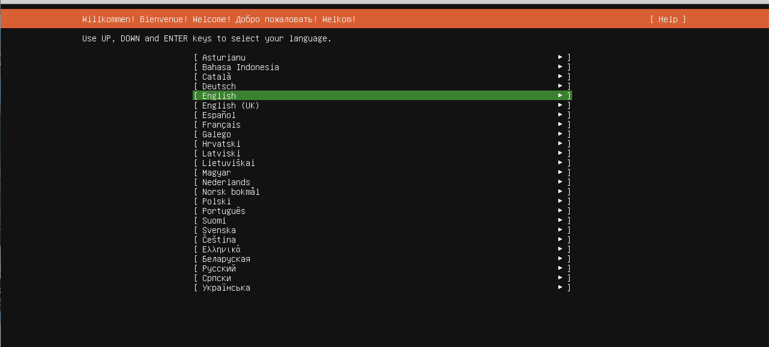

Next, we are going to be prompted with an option to update to the latest version of Ubuntu or not. Either one you choose is up to you!

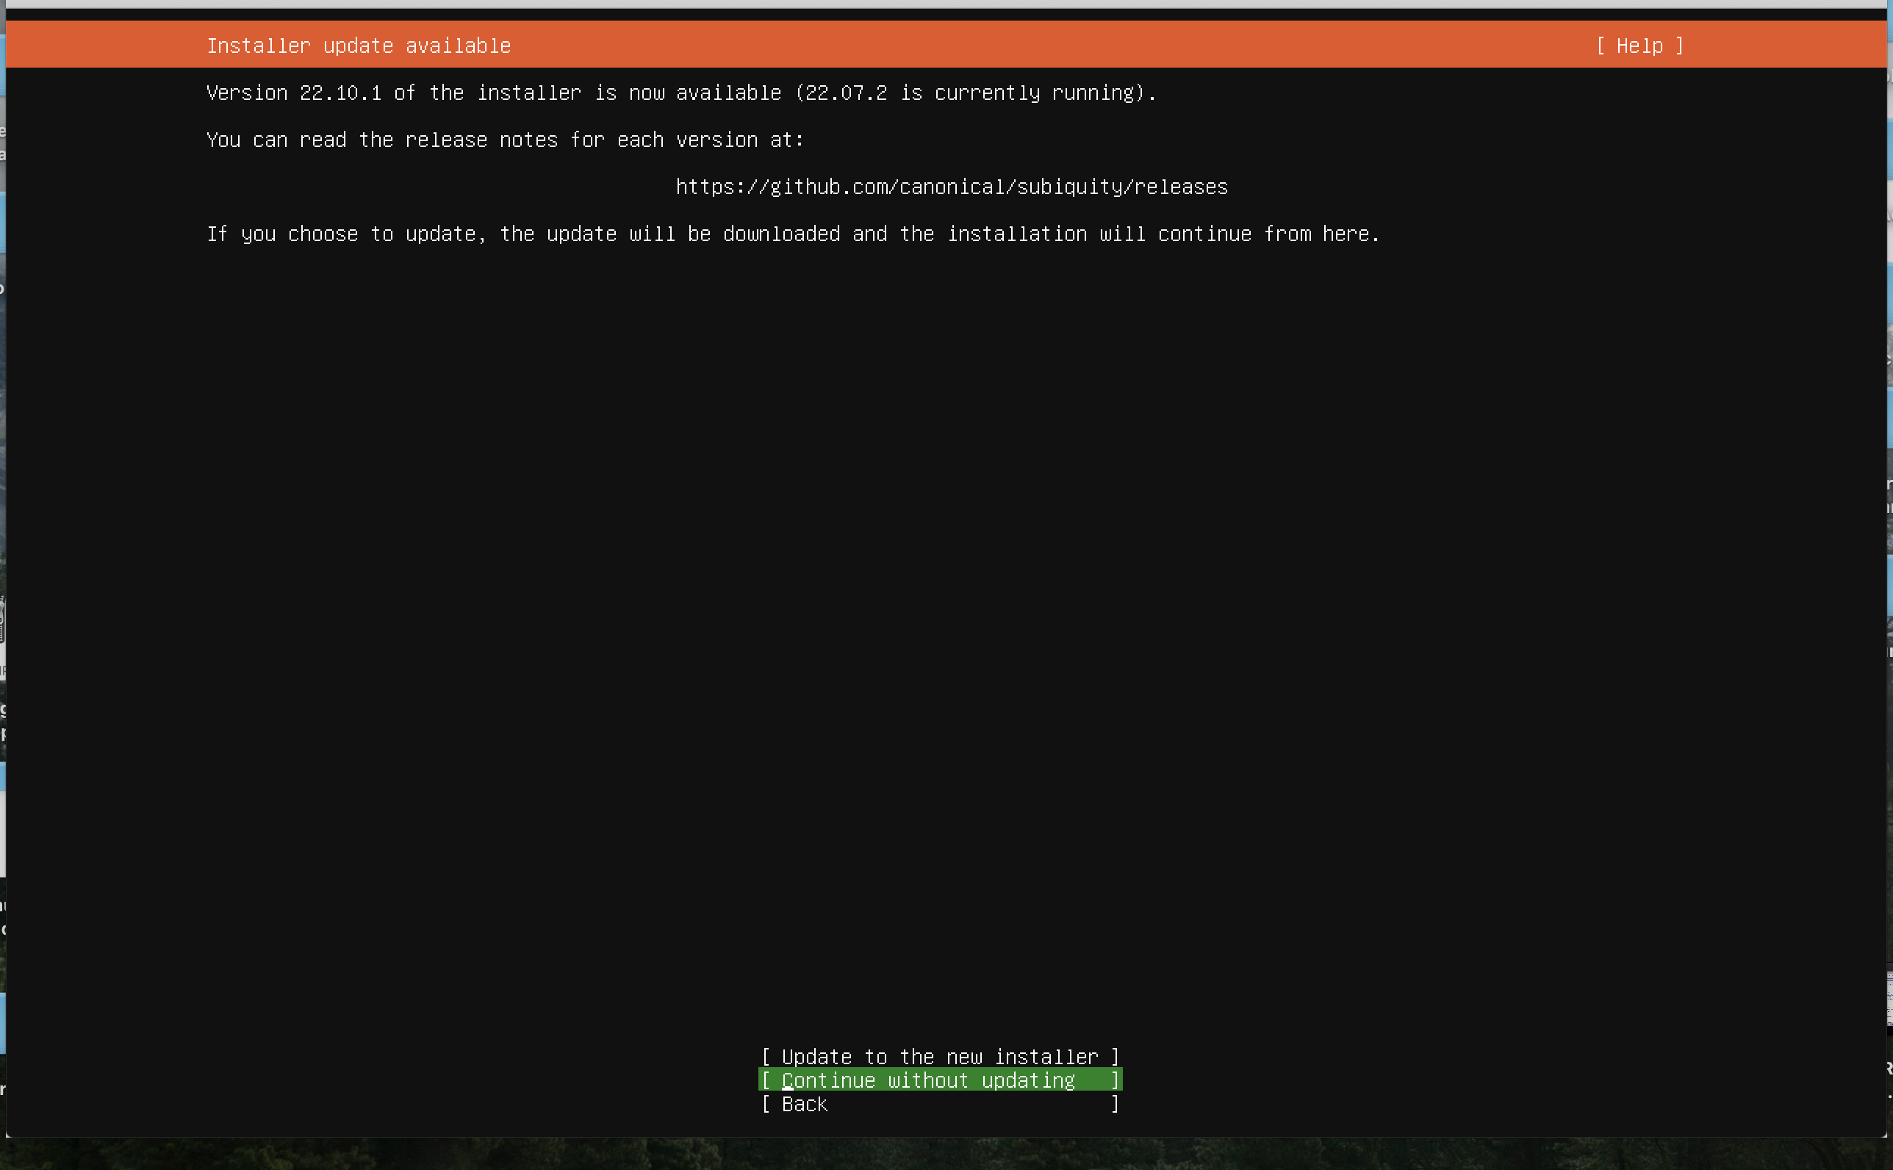

Once this is done, we will also be prompted for keyboard selection. Change this to whatever you feel comfortable with or leave it as default if you want it to be:

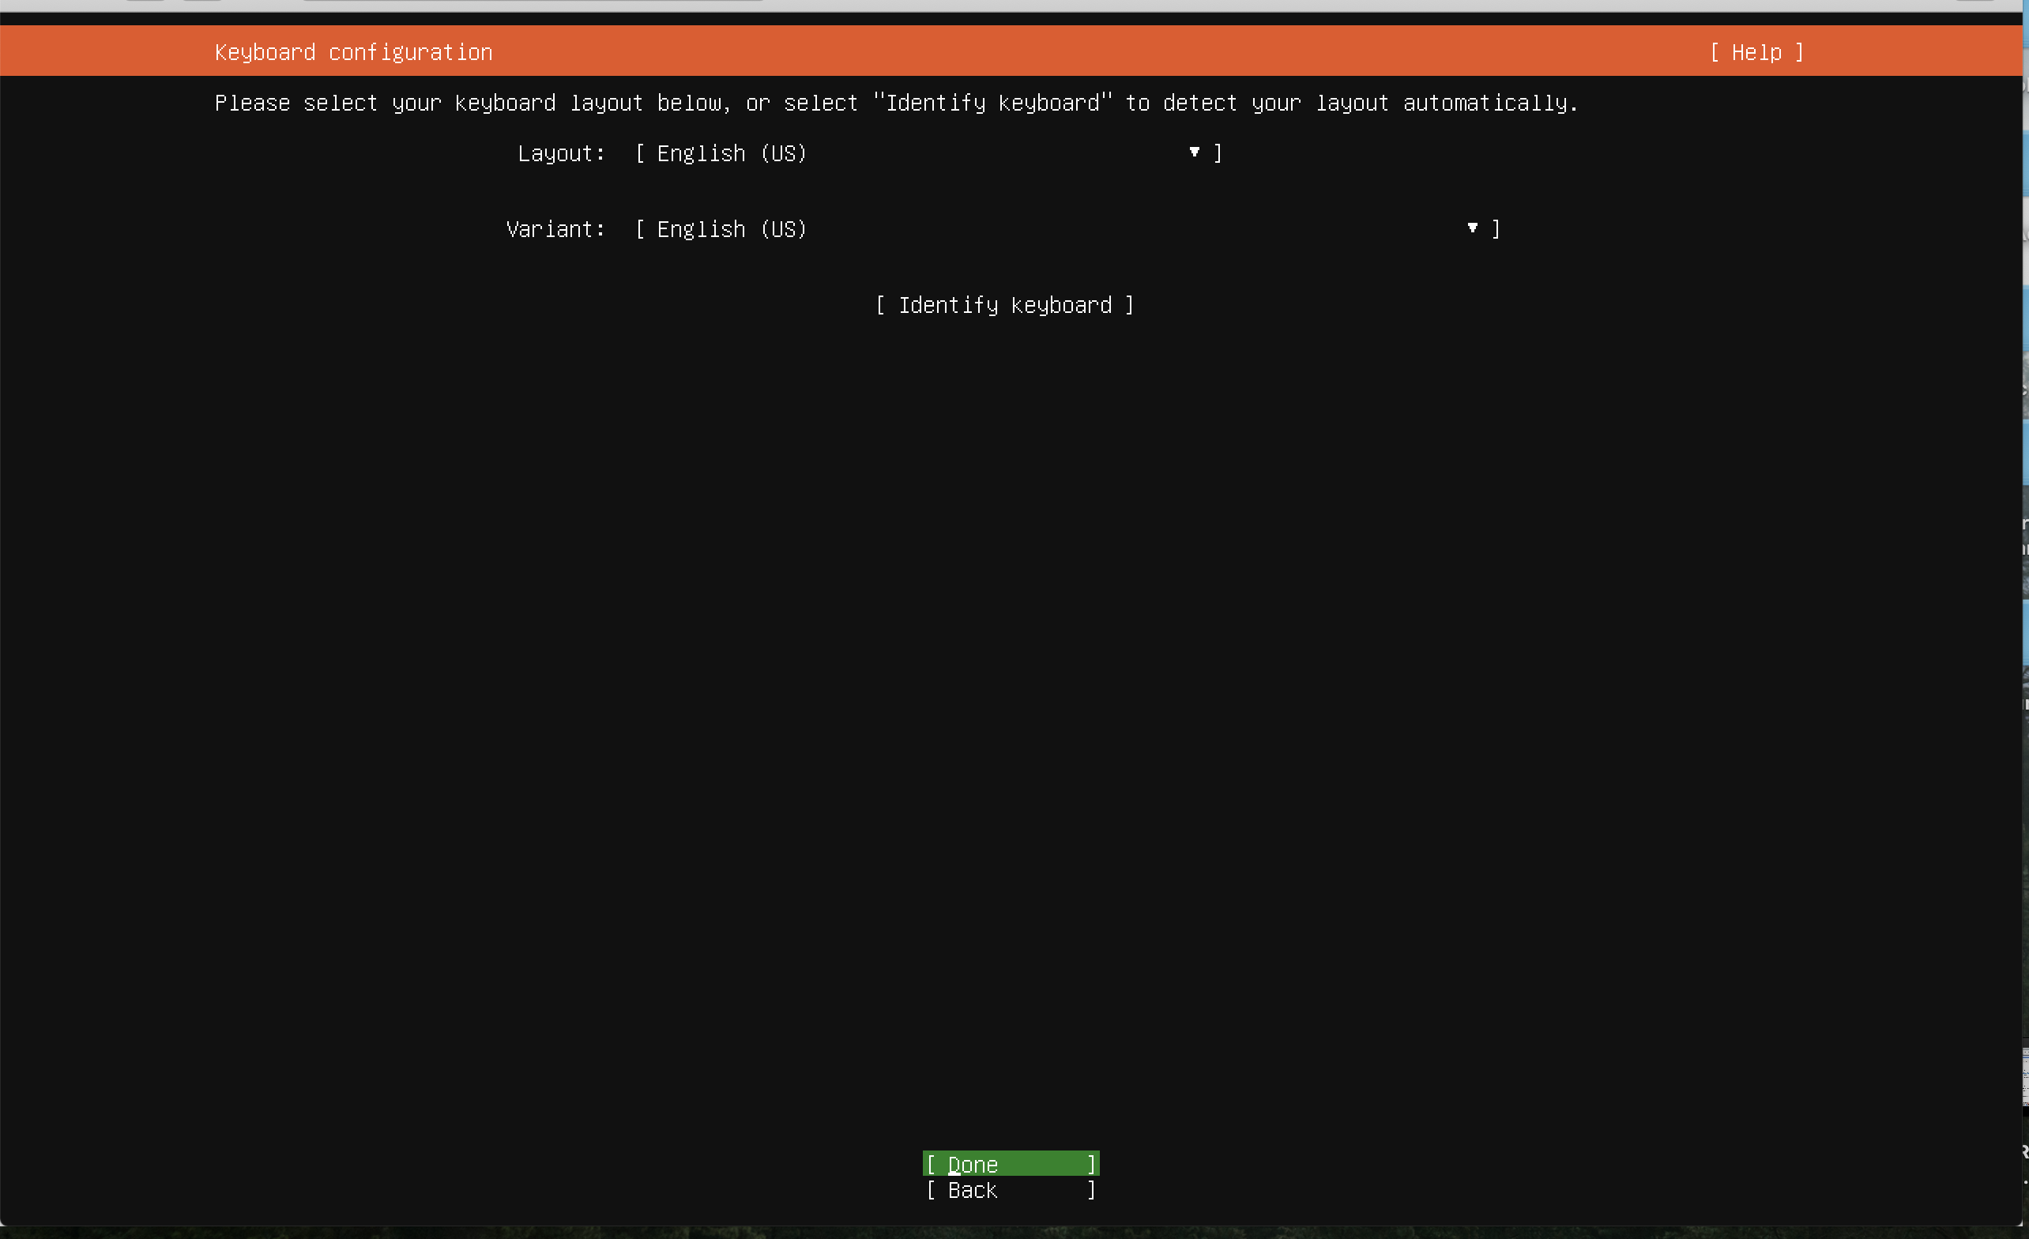

We will next be prompted to choose the type of Ubuntu installation we want. This can be the minimized or regular server. Please choose the First option as shown in the image below. :

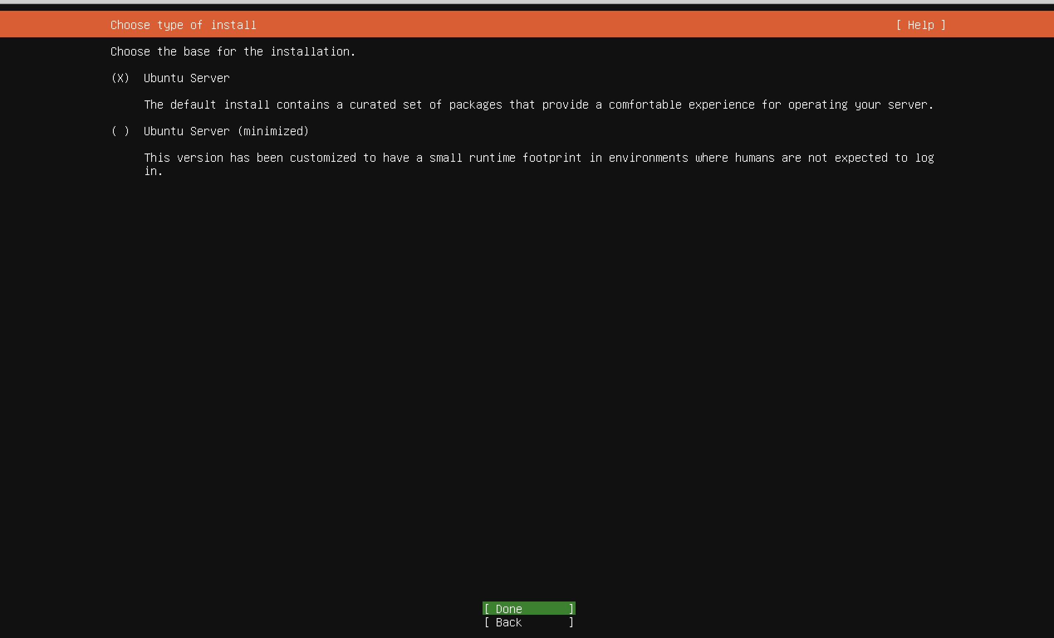

Next We can decide what network connection our server will be on. For this labs purposes, use the network that is connected to your host computer. This will happen automatically. Then you can select done and continue to the next step.

*Note after this step you will be prompted with proxy address and mirror address. You can skip through them for this lab and leave them as default.*

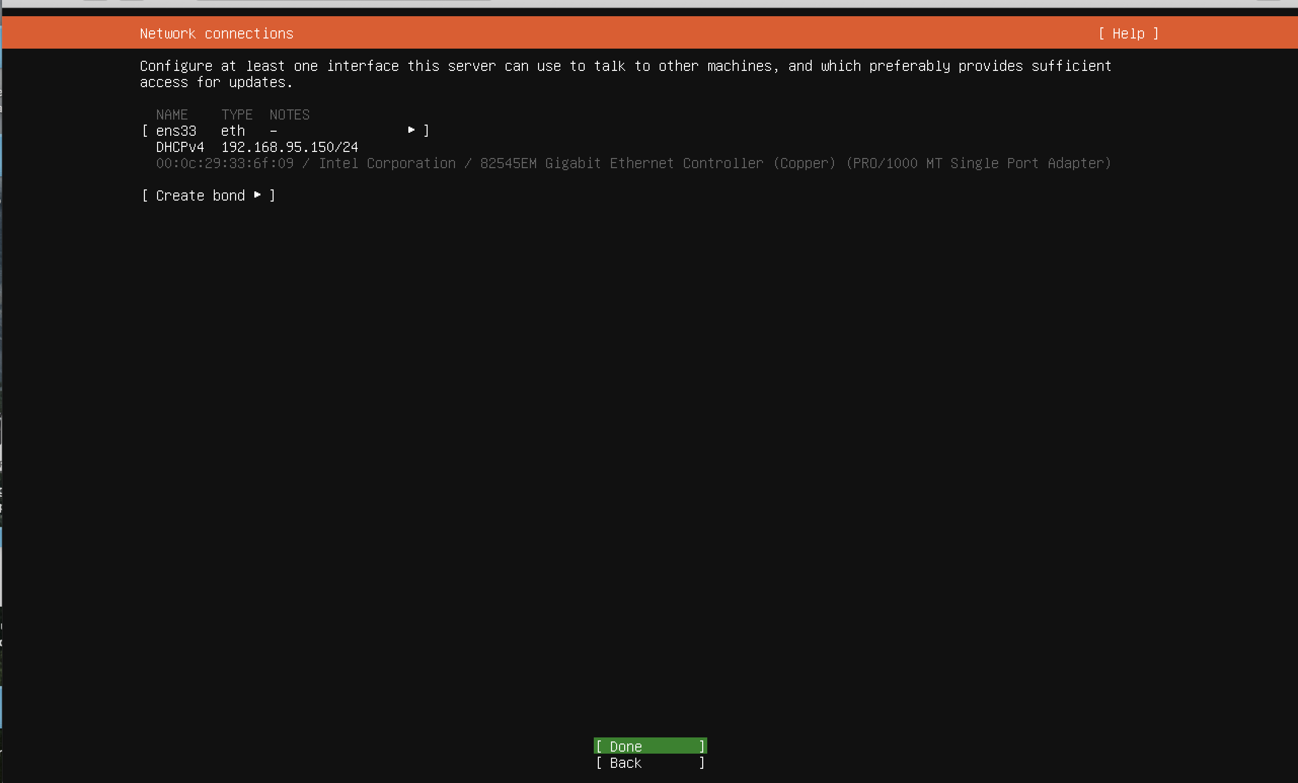

After this you can select the storage configuration for the Ubuntu Server. You can leave it as entire disk as default or select Custom storage layout if you so choose. It looks like this:

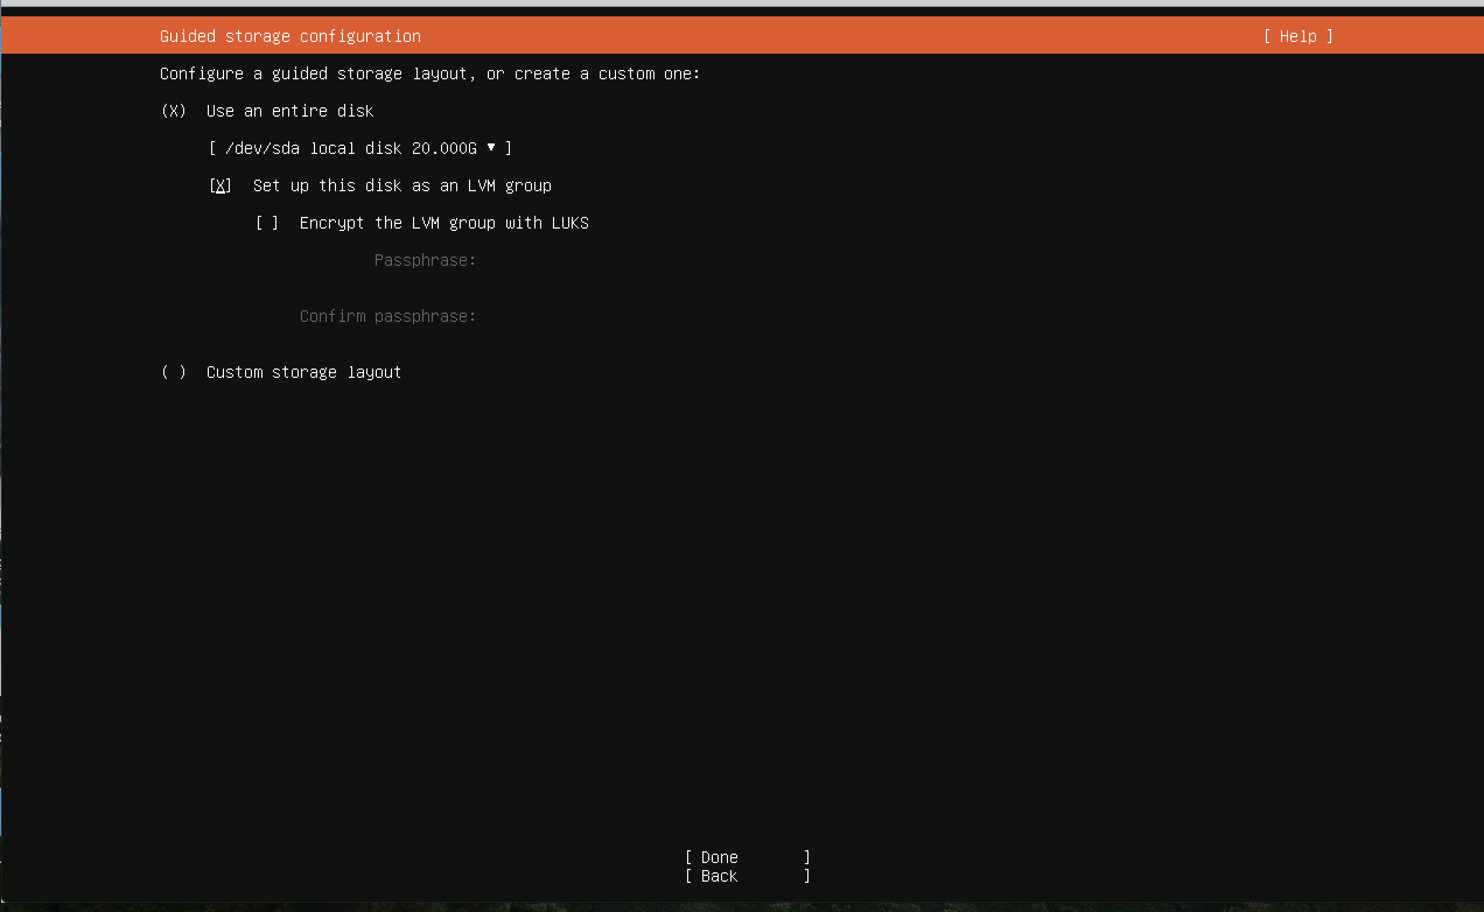

We will then be prompted to make our username, server name, and password:

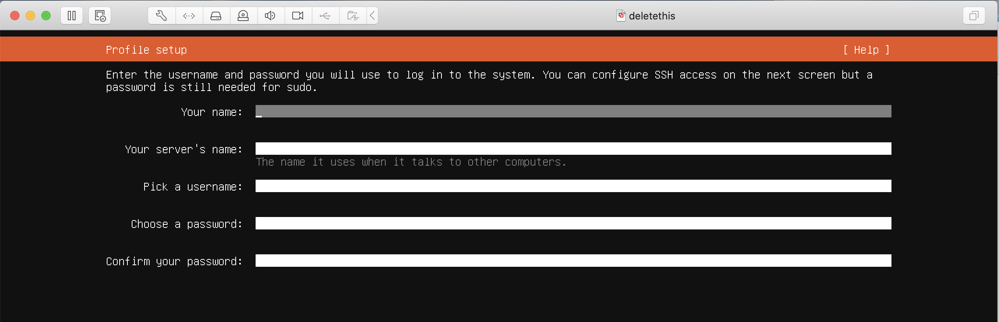

We then have the choice to install openssh server. This is up to you!

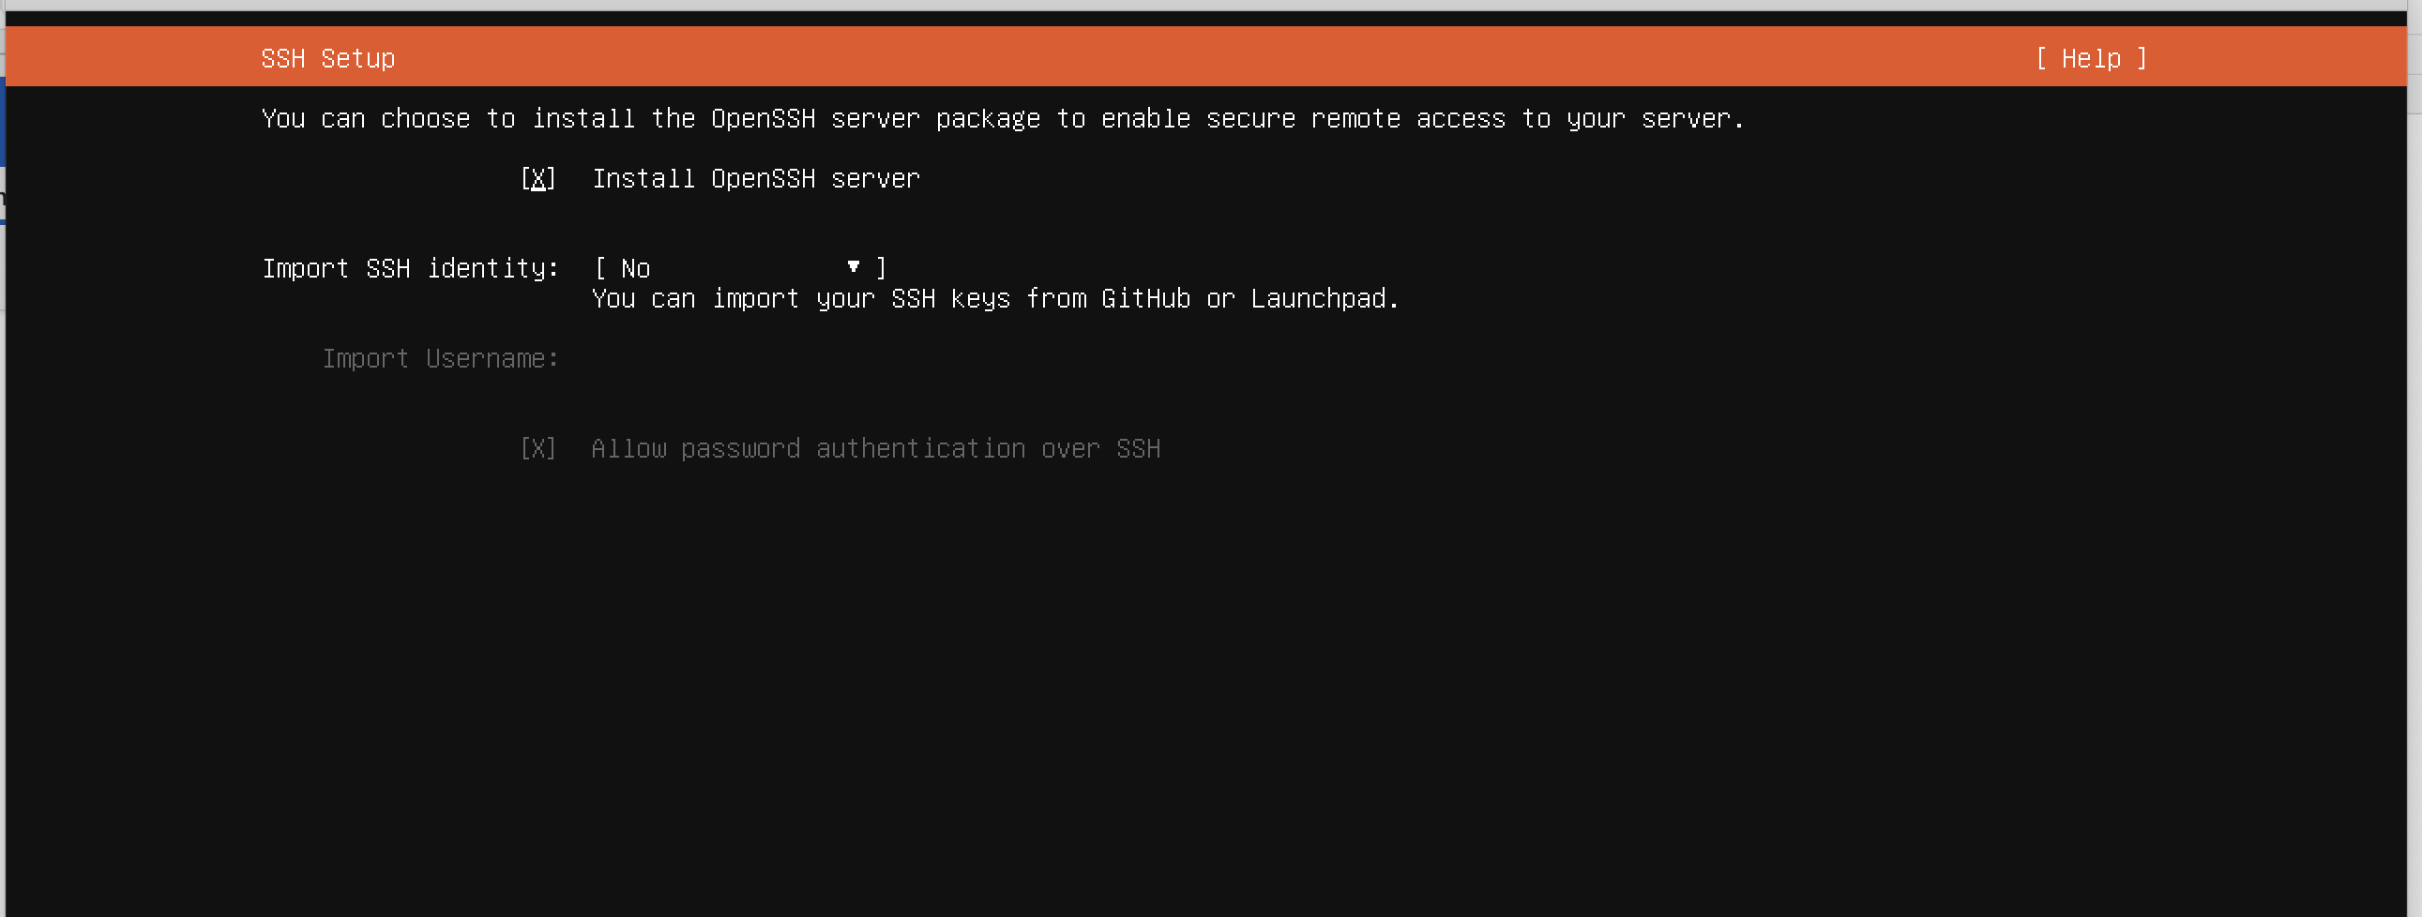

We also will have the choice to install a wide variety of different applications that will be installed with the server. This is entirely up to the user and is free for you to select. There is no requirements here, just whatever you like. After this we can move on to install.

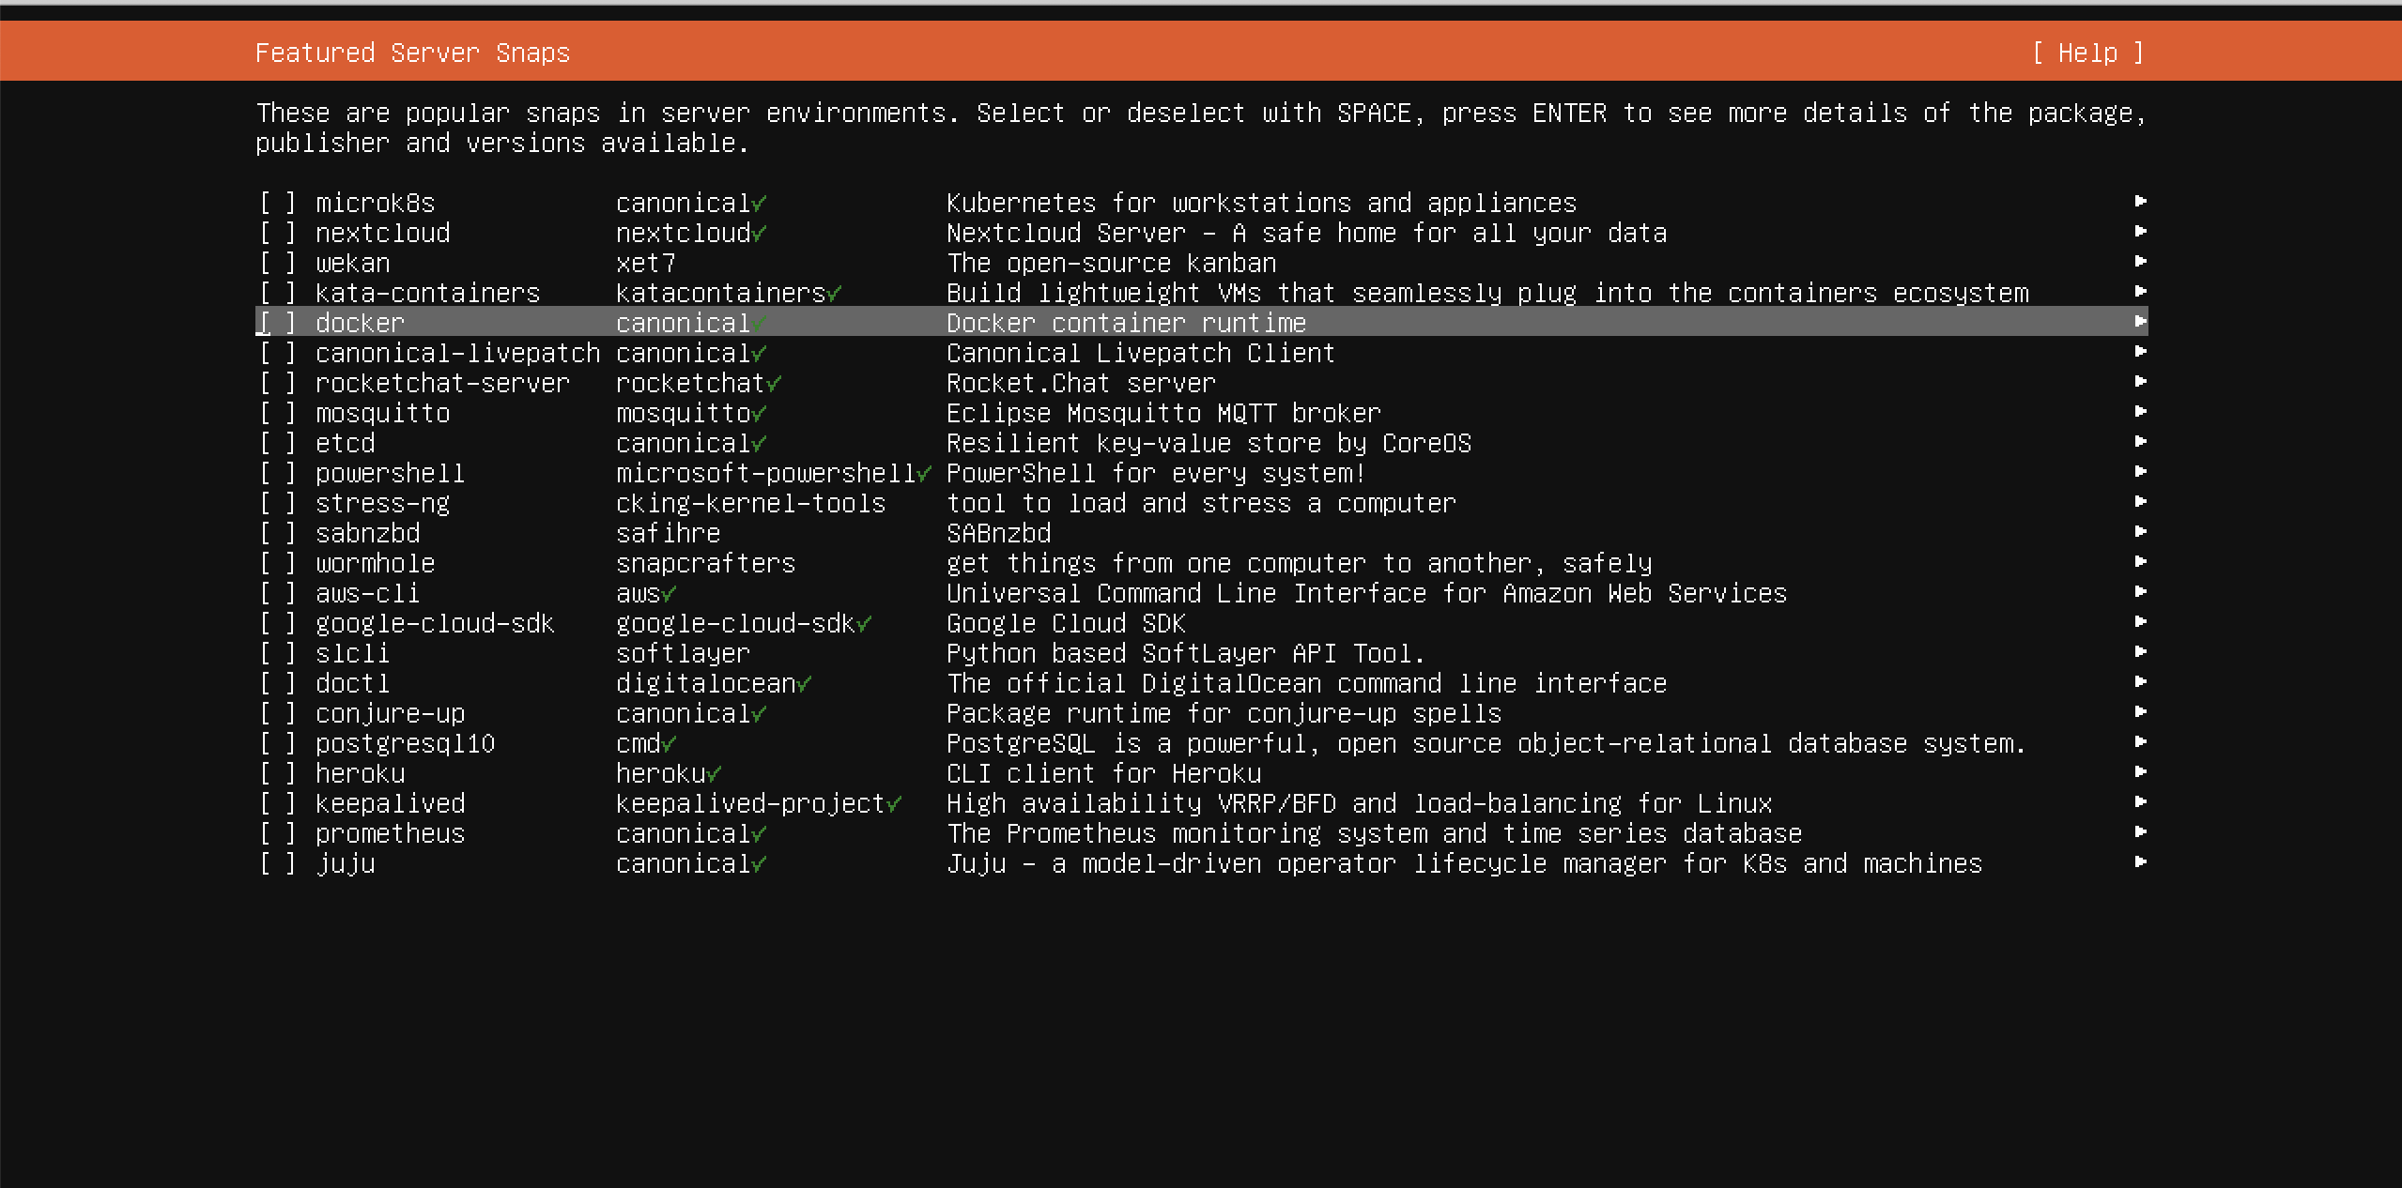

Once we move on, install begins! Your screen should look like this!

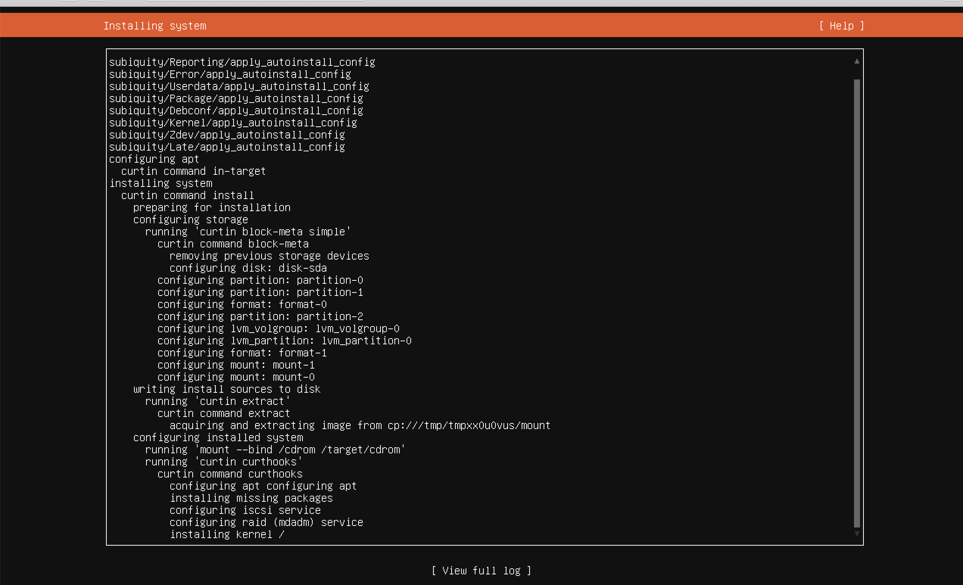

Once the installation is done you will be prompted with a reboot button. Make sure to click that and you will then be prompted to log in with whatever credentials you set up and ta-da! You now have your ubuntu server.

